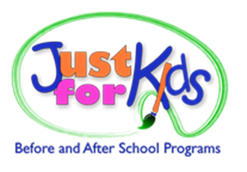
Marketing Internship
Just for Kids, a not-for-profit leader in the child care field, has internship opportunities at our main office in Williamsville, NY. We manage year-round programs for local School Districts and select private schools, serving almost 1,000 local students and employing over 150 staff. Our internship program offers hands-on experience in a dynamic and rewarding environment, providing valuable opportunities to contribute to the coordination and success of our before and after school programs.
Our team offers provides hand on experience in marketing, communication, public relations and large-scale project which may include: developing a strategic marketing plan, creating e-newsletters and other client communication, developing a social media campaign, create promotional footage for our website, etc. Interns will also work with the Human Resource team in developing recruitment flyers and social media postings.
Internships are available for fall, spring, and summer semesters. Hours are flexible to suit the needs of a college student and average 10-15 hours per week, or per your college’s requirements for course credit. Internship hours take place during our office hours M-F 9:00am-5:00pm. Just for Kids will provide any documentation needed per college requirements for course credit.
Requirements:
- Currently a college Junior or Senior majoring in Marketing, Communications or Business-rated field
- Preference given to students majoring in a Marketing related field
- General knowledge of marketing, communications and public relation practices and disciplines
Expectations:
- Strong communication skills (written and verbal), strong organizational skills and reliable
- Able to work well independently and as part of a team
- Able to follow directions, contribute openly, and have a flexible, proactive can-do attitude
- Ability to work proficiently with Microsoft Office Suite
- Ability to use marketing design tools and manage social media platforms
Please email your resume with a statement of interest to: HR@justforkidsonline.org

